

Émilie Mayodon

Akash Singh

6 December 2019

Computer Science

And the Future

Table of Contents

Introduction 3

Computer Science and the Future 3

Common careers and salaries 4

Average entry salary and annual raise: 4

Data Chart: 5

Degrees and Demands 6

Degrees required and demands percentages: 6

Data chart: 7

ER Diagram 8

Ethical Dilemma 9

Online activity/privacy: 9

Table of gains and losses: 9

Table of duties and responsibilities: 9

CONCLUSION: 10

References 11

# Introduction

## Computer Science and the Future

The future holds a promising outlook for computer science graduates as technology advances faster than ever. Every businesses and companies need certain types of programmer, web designer, etc. to maintain their website and media or their computer systems. As technology has a bigger impact in our everyday lives - and we hardly live without it – computer science offers a vast employment rate and a high starting salary for graduates. Technology has its perks, but it can be the foundation of ethical dilemmas starring privacy. This report will contain the multitude of careers in this domain accompanied by the forecast of employment for the upcoming computer science alumni, and the issues concerning public privacy.



# Common careers and salaries

## Average entry salary and annual raise:

|  |  |  |
| --- | --- | --- |
| **Jobs** | **Average Salary (Entry-Level)** | **Annual Average Raise** |
| Software Developer | $65,000.00 | $1,690.00 |
| Database Administrator | $61,000.00 | $1,586.00 |
| Computer Systems Analyst | $67,460.00 | $1,753.96 |
| Systems Manager | $67,000.00 | $1,742.00 |
| Web Developer | $51,000.00 | $1,326.00 |
| Information Security Analyst | $64,600.00 | $1,679.60 |
| IT Architect | $91,000.00 | $2,938.00 |
| Computer Programmer | $52,000.00 | $2,531.10 |
| Software Engineer | $77,000.00 | $2,002.00 |
| Information Researcher | $86,000.00 | $2,236.00 |
| Video Game Developer | $50,276.00 | $1,307.18 |
| IT Project Manager | $86,126.00 | $2,239.28 |
| Computer Network Architect | $104,650.00 | $2,720.90 |
| Canadian Annual Interest Rate |  | 2.60% (2019) |

## Data Chart:

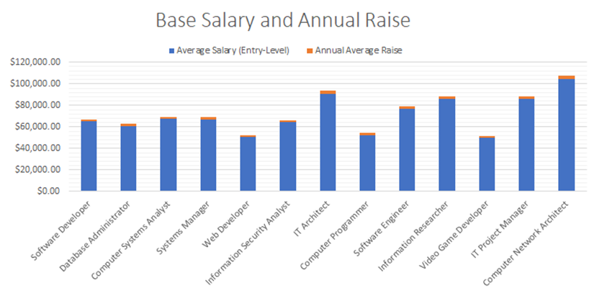

The following diagram demonstrates the starting salary of common careers in the Computer Science Field, and its annual average raise

The current Canadian annual average salary increase is 2.60%, this leads to a greater pay growth. Jobs with a generally high demand tend to receive a bigger annual increase.

As shown, computer network architect has the highest paying job with the highest annual increase, while video game developer, statistically, is the lowest paying job and with the lowest salary raise.

# Degrees and Demands

## Degrees required and demands percentages:

|  |  |  |
| --- | --- | --- |
| **Jobs** | **Degree Required** | **Demands** |
| Software Developer | Bachelor's Degree | 21% |
| Database Administrator | Bachelor's Degree | 9% |
| Computer Systems Analyst | Bachelor's Degree | 9% |
| Systems Manager | Bachelor's Degree | 11% |
| Web Developer | Associate | 13% |
| Information Security Analyst | Bachelor's Degree | 32% |
| IT Architect | Bachelor's Degree | 8% |
| Computer Programmer | Bachelor's Degree | -7% |
| Software Engineer | Bachelor's Degree | 21% |
| Information Researcher | Master's Degree | 16% |
| Video Game Developer | Bachelor's Degree | -40% |
| IT Project Manager | Bachelor's Degree | 11% |
| Computer Network Architect | Bachelor's Degree | 6% |

## Data chart:

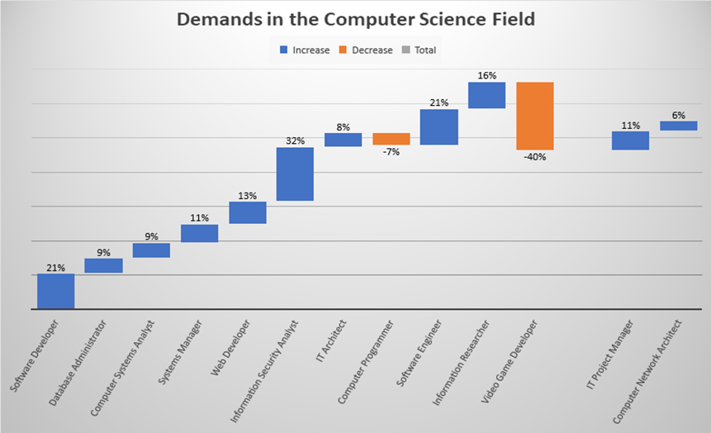

This waterfall chart shows the current percentage of demands for a list of common jobs in the Computer Science Field.

Unfortunately, video game developers are in high decrease of demands, while information security analyst is soaring in demands.

# ER Diagram

# 

# Ethical Dilemma

## Online activity/privacy:

Should we be using social media knowing that there is a risk of invasion of our privacy?

### Table of gains and losses:

|  |  |  |
| --- | --- | --- |
|  | Gains | Losses |
| Public | * Public recognition (fame) * Express oneself * Entertainment purposes * Way to distract oneself from other problems | * Intruding personal life * Cyberbullying * Leak of private information/photos * Circulation of fakes news * Trace everything back to you |
| Government | * Tracking potential criminals | * Total surveillance of citizens (Big Brother, Edward Snowden) * Loss of public trust |

### Table of duties and responsibilities:

|  |  |  |
| --- | --- | --- |
| Duties | Public | Government |
| Public | * Report share of unwanted private information * Don’t cyberbully * Think twice before posting online * Check the reliability of the sources | * Report scams and cyber crimes |
| Government | * Be honest about the surveillance system * Provide a safe place * Stop online trafficking of photos   Answer: Yes, we should be able to use social media at our risks, as long as you know how to be safe online and not be a nuisance to others. | * Filter what should be watched and registered |

# CONCLUSION:

There are many paths to take in the computer science field and various options for anyone with an interest. With the employment rate very high, it is a good idea to consider a career path in this area if you are looking for a good pay and a great job.

As technology is part of our everyday lives, it follows us everywhere. Having its ups and downs, it can create controversial topics and ethical questions concerning our use of technology.

# References

<https://www.internationalstudent.com/study-computer-science/careers-in-computer-science/>

<https://www.thebalancecareers.com/top-jobs-for-computer-science-majors-2059634>

<https://www.computerscience.org/careers/>

<https://www.bls.gov/ooh/computer-and-information-technology/home.htm>

<https://www.randstad.ca/best-jobs/best-it-and-technology-jobs/>